**EECS 118**

**Term Project**

**Gaurav Venkatesh**

**28826069**

**About the Project and why I chose to do it**

Being the last project for EECS 118, I decided to make a website that could possibly benefit me. Ever since I came to UCI, I’ve lacked the skills to make a dish that was edible and I could not do anything about it other than buy food from outside. All the websites that I visited was very cluttered and intimidating with the amount of content. So I took the opportunity to make a website which helps people cook. Which looked simple more than anything. Which is user friendly and has limited operations in order to not scare a newbie.

So after I started the project it was hard to find free apis to to finish my project. I was on the verge of giving up and changing my project to something simple, but I stuck to it after a found an api food2fork. It did not have much functionality but it was better than nothing, so I started playing with it and I have dumbed down the website so that a college can figure to make something with ease.

sufficient?

**Functionality of your service**

* Finds recipes based on what you like
* Finds recipe based on cuisine
* Finds recipes based on the ingredients you have.
* Easy like to order pizza.

**How is this better than the host website?**

It is simpler than the main website. It has less entries per page giving the viewer more clarity as to what he wants to make. It lets you choose based on ingredients and it lets you order pizza. Since it has lesser entries to load it also loads faster. It also clearly demarks the ingredients needed to make it and stops wasting the user's time if he doesn't have the ingredients.

**Design:**

The project can be classified primarily as the mentioned model. A user sends his query to the second php page and that further send the id of the recipe clicked to the next php page which get the recipe ingredients and then sends the user to get the recipe itself.

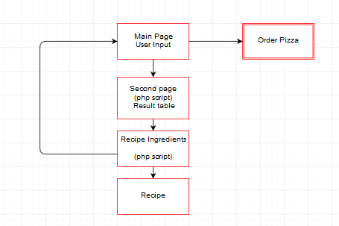

**UI: user interface**

The First Page is a welcome page to the website.

It contains all the possible choices one can make and input .

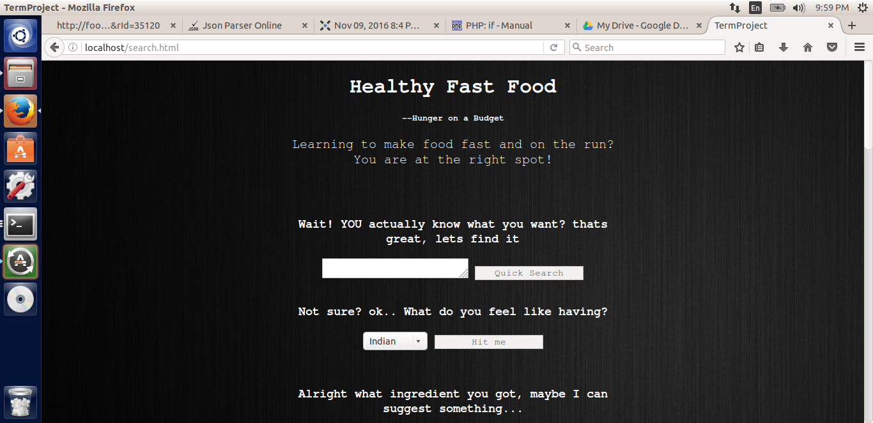

Towards the end of the page, one can click on the link and take you to ordering pizza.

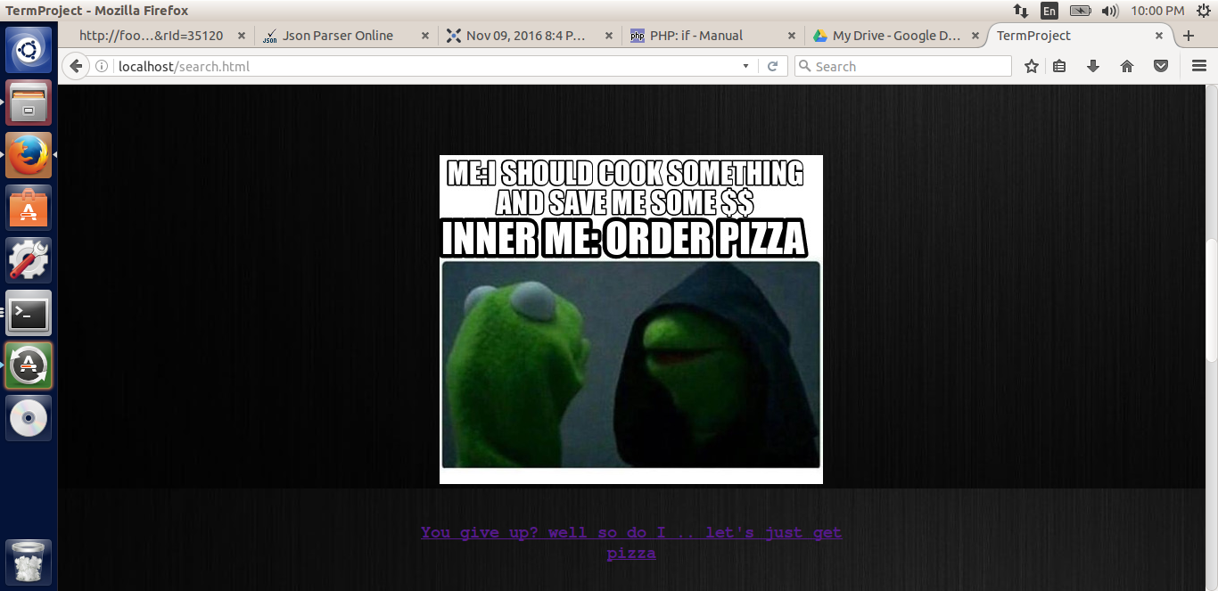

The image below is page 2. Page 2 contains the result set of the query searched in result one. Every possible situation is handled in the page 2 and is written in php.

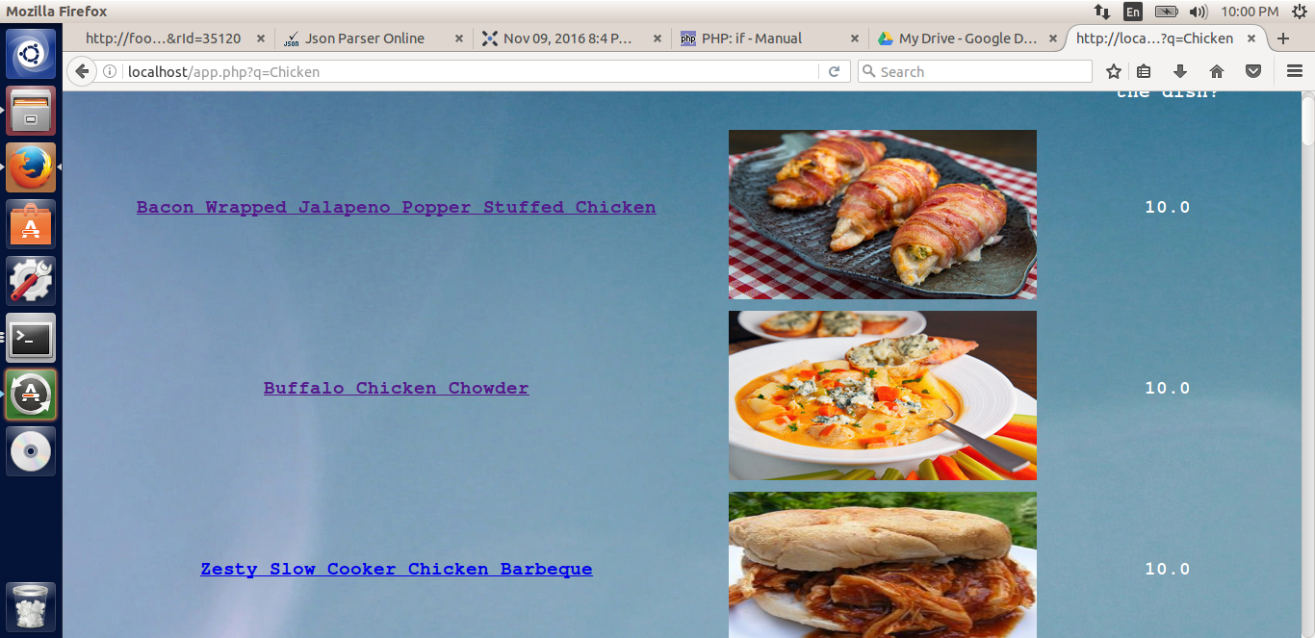

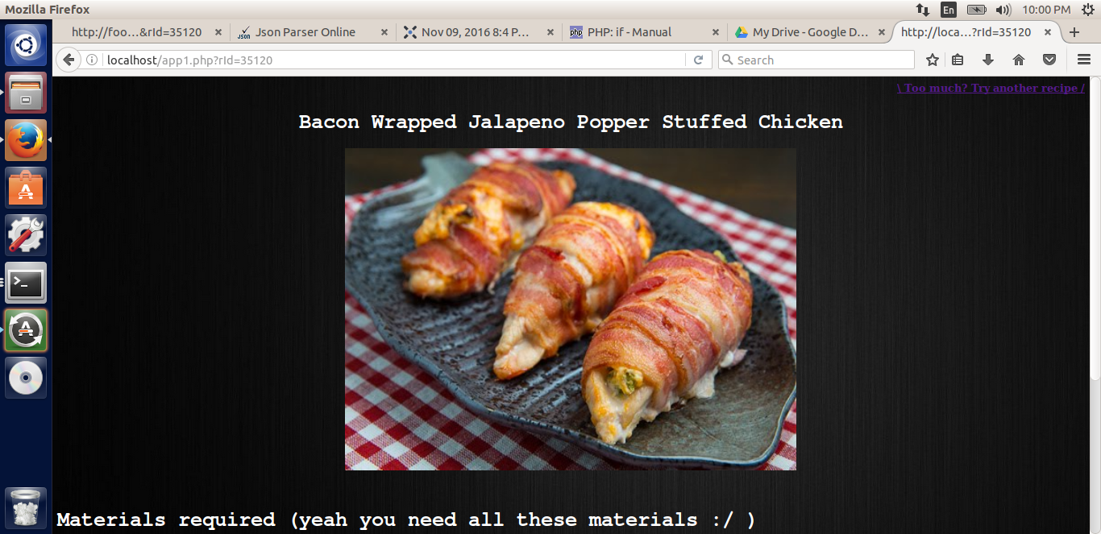

The picture above is the result of clicking on one of the links. It shows you the name of the dish and also below it asks you for all the materials required for the dish

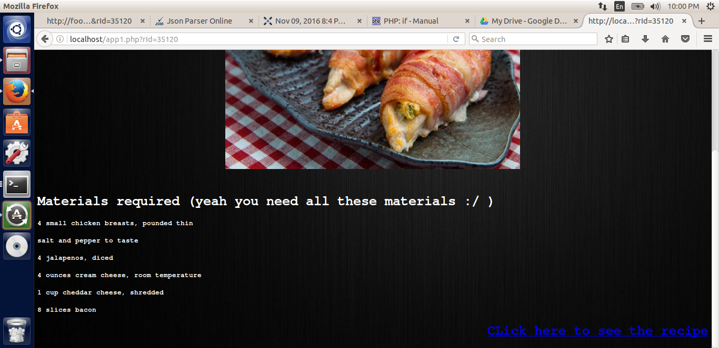

The materials required for the dish is mentioned and upon clicking the Recipe option takes you to the recipe page and one can begin cooking.

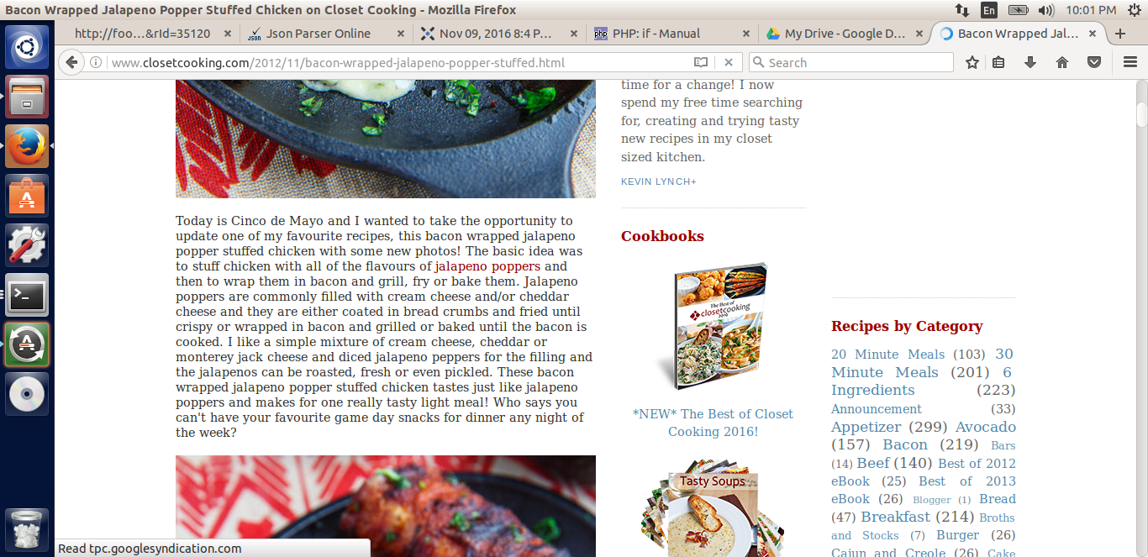

(7) Testing: a testing plan and how you did it

Testing was a real challenge, Being an amatuer in the website making field, I was unaware of how to test my code. Given that my platform of working was linux I had to use the terminal and vim to actually even write the code. I eventually learned that the web browsers themselves have a test and debug function, even though they aren't as effective as a eclipse platform. I had issues where I was trying to parse information from websites I could not decipher as to where exactly was there a problem with the code, just know that a certain segment had problems. I had to place echo statements all over my code and output my answers to see what was coming out and where the code was failing. But because of this, I learned to code better and not be dependent on eclipse or netbeans to find my mistakes for me. I started consciously looking into what I typed and debugging by the line.

**Source Code**

**I apologize for the messy code, but I had to keep some of the test scenarios in case the program ever breaks in order to find out my error.**

**The First page is the html page**

*<!DOCTYPE html>*

*<html>*

*<head>*

*<title>TermProject</title>*

*<link type = "text/css" rel = "stylesheet" href = "style.css" />*

*<div class= "headers">*

*<h1>Healthy Fast Food</h1>*

*<h5> --Hunger on a Budget</h5>*

*</div>*

*</head>*

*<body>*

*<div class= "container">*

*<div class="para">*

*<p>Learning to make food fast and on the run. You are at the right spot.</p>*

*</div>*

*<div class ="Content">*

*<form action='app.php'>*

*<textarea name='q' rows='10' cols='30'></textarea>*

*<br />*

*<input type='submit'>*

*</form>*

*</div>*

*</div>*

*</body>*

*</html>*

**The next page in the series is the php page showing the results of the input.**

*<?php*

*echo '<body background="http://img.wallpaper.sc/desktop/images/5k/desktop-pc-5120x2880-wallpaper_00009.jpg" >';*

*$key = '716fe551154fdcff6e3c448c2fac6135';*

*$q = $_GET["q"];*

*$json = file_get_contents('http://food2fork.com/api/search?key=' . $key . '&q=' . $q); # Get JSON from food2fork*

*$obj = json_decode($json); # Decode JSON into STD object*

*# echo $obj->count ."<br />"; # print out the count variable*

*$count = $obj->count;*

*$recipes = $obj->recipes;*

*$test = array_values($recipes)[0];*

*echo "<table border='0'cellpadding='5' cellspacing='5' >";*

*echo "<tr>";*

*echo '<td> <h2 style="text-align:center; color:white;font-family: Rockwell,Courier Bold,Courier,Georgia,Times,Times New Roman,serif;*

*"> Dish</h2> </td>';*

*echo '<td> <h2 style="text-align:center; color:white;font-family: Rockwell,Courier Bold,Courier,Georgia,Times,Times New Roman,serif;*

*"> How it could look</h2></td>';*

*echo '<td> <h2 style="text-align:center; color:white;font-family: Rockwell,Courier Bold,Courier,Georgia,Times,Times New Roman,serif;*

*"> How did people rate the dish?</td>';*

*echo "</tr>";*

*for ($x = 0; $x < $count; $x++) {*

*$val = array_values($recipes)[$x]; # val = recipes[x]*

*echo "<tr>\n";*

*# echo "<td>$val->title</td>\n";*

*$rId = $val->recipe_id;*

*echo '<td><h2 style="text-align:center; color:white;font-family: Rockwell,Courier Bold,Courier,Georgia,Times,Times New Roman,serif;*

*"> <a href="app1.php?rId=' . $rId . '">' . $val->title . '</a></h2></td>';*

*$img = $val->image_url;*

*echo '<td><img src="' . $img . '" width = "400" height = "220" /></td>';*

*$r = (100 == $val->social_rank) ? '10.0' : '9.5-9.8';*

*echo '<td><h2 style="text-align:center; color:white;font-family: Rockwell,Courier Bold,Courier,Georgia,Times,Times New Roman,serif;*

*">' . $r . '</h2></td>';*

*echo "</tr>\n";*

*}*

*echo "</table>\n";*

*?>*

**The page after that is the app1 page with more information:**

*<?php*

*$key = '716fe551154fdcff6e3c448c2fac6135';*

*$q = $_GET["rId"];*

*# $q = '35120';*

*echo '<body background="http://faceitformobile.com/wp-content/uploads/2014/06/Face-It-black.jpg" >';*

*$json = file_get_contents('http://food2fork.com/api/get?key=' . $key . '&rId=' . $q); # Get JSON from food2fork*

*$obj = json_decode($json,true); # Decode JSON into STD object*

*$img = $obj['recipe']['image_url'];*

*$title = $obj['recipe']['title'];*

*# $social = $obj['recipe']['social_rank'];*

*echo '<h4 style="text-align:right;color:white"><a href=search.html> \ Too much? Try another recipe / </a> </h4>';*

*echo '<h1 style="text-align:center;color:white;font-family: Rockwell,Courier Bold,Courier,Georgia,Times,Times New Roman,serif;*

*">' .$title. '</h1>';*

*echo '<p style="text-align:center"><img src="' . $img . '" width = "700" height = "500" align="center" /></p> <br>';*

*echo '<h1 style="text-align:left;color:white;font-family: Rockwell,Courier Bold,Courier,Georgia,Times,Times New Roman,serif;*

*"> Materials required (yeah you need all these materials :/ )</h1>';*

*$output="<ul>";*

*foreach ($obj['recipe']['ingredients'] as $ing){*

*echo '<h4 style="text-align:left;color:white;font-family: Rockwell,Courier Bold,Courier,Georgia,Times,Times New Roman,serif;*

*">' . $ing .'</h4>';*

*}*

*$outlink = $obj['recipe']['source_url'];*

*echo '<h1 style="text-align:right;color:white;font-family: Rockwell,Courier Bold,Courier,Georgia,Times,Times New Roman,serif;"><a href="' . $outlink . '">CLick here to see the recipe</a>';*

*?>*

**The php stylesheet and the css style sheet are similar just specifically designed for each of the type of pages so I posted the css page here.**

*input[type=submit] {*

*width: 170px;*

*border: 1px dotted #999;*

*border-radius: 0;*

*font-family: Rockwell,Courier Bold,Courier,Georgia,Times,Times New Roman,serif;*

*-webkit-appearance: none;*

*}*

*body {*

*background: url('http://faceitformobile.com/wp-content/uploads/2014/06/Face-It-black.jpg');*

*font-family: Rockwell,Courier Bold,Courier,Georgia,Times,Times New Roman,serif;*

*}*

*h5{*

*color: white;*

*text-align: center;*

*font-family: Rockwell,Courier Bold,Courier,Georgia,Times,Times New Roman,serif;*

*}*

*div.content{*

*color: white;*

*text-align: center;*

*height:2000px;*

*width:80%;*

*margin:0px auto;*

*}*

*div.container{*

*color: white;*

*text-align: center;*

*height:2000px;*

*width:80%;*

*margin:0px auto;*

*}*

*div.headers{*

*height:50%;*

*width:100%;*

*margin:0px auto;*

*}*

*div.para{*

*height: 100%;*

*width: 50%;*

*margin:0px auto;*

*}*

*h1 {*

*color: white;*

*text-align: center;*

*font-family: Rockwell,Courier Bold,Courier,Georgia,Times,Times New Roman,serif;*

*}*

*p {*

*font-size: 20px;*

*}*

**Deployment: The platform for development and deployment, status of implementation, what is working and what is not**

Everything is working but the 3rd search feature with the ingredients is a little buggy, instead of particularly choosing the ingredients you have it looks if the ingredient is present in the dish and displays the result. You will need php installed on the server in order to run my project. Other than that I use basic html sheet and also a css page to accomplish all my tasks.

**Conclusion and Future Work**:

**lessons learned, and what could be done in the future.**

In the future, before I start a project I will research more on the resources available to make the project, I have learned not to rush into projects and plan everything out before starting the work especially when it comes to website. I spent a considerable amount of time on designing the website. And I came to realize that I needed to use php in order to make my project work, so I not only learned php but also had to run the entire thing on my linux terminal as my apache did not have php installed. I learned a lot of the command line arguments thanks to this project and overall spent the time well on accomplishing my tasks and meeting with my milestones. I could have added more features to the website as I wanted to add a youtube function to search for the dishes directly but I could not as I did not have the time to make it happen as we had more homework for the class. I will however work on it over the winter break and make it better and more user friendly.

-Gaurav Venkatesh